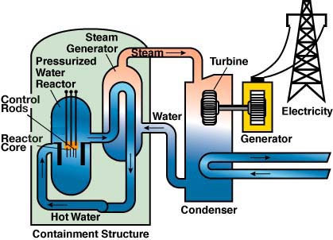
How a nuclear reactor works

Why am I doing this?

- to describe and explain the process of nuclear chain reaction;
- to describe the basic construction of a fission reactor and explain the role of the fuel rods, control rods and the moderator;
- to describe the use of nuclear fission as an energy source;
- to describe the peaceful uses of nuclear fission.

To do

Using the information you have been given and other sources,
- provide a large and carefully labelled diagram showing a nuclear reactor. Label the fuel rods, control rods and coolant.

Questions

- Nuclear fuel

- What types of nuclear fuel are commonly used in nuclear reactors?

- What fissionable isotopes are used in nuclear reactors?

- What is a ‘fuel rod’?

- Moderator

- What does a moderator do in a nuclear reactor, and why is moderation necessary?

- What substances are commonly used as moderators? What do they have in common?

- Explain what is meant by a ‘thermal’ neutron.

- Control rods

- What is the purpose of control rods in a nuclear reactor?

- What substances are used in control rods? What do they have in common?

- What is a ‘scram’?

- Explain the meaning of ‘neutron poison’. Why do neutron poisons accumulate during the operation of a reactor, and how do they affect the operation of the reactor?

- Coolant

- What is the purpose of a coolant in a nuclear reactor?

- What substances are used as coolants in BWR, AGR and PWR power stations? Are there any other types of coolant available?

- Why are the primary and secondary cooling loops kept separate?

